Eksamen 23
Exercise 1
Q1 ill answer by writing the cashflows and a discountfactor vector
$$B_{A}=\left(\begin{matrix}5 & 5 & 105 & 0 & 0 & 0 & 0\end{matrix}\right)$$
$$B_{B}=\left(\begin{matrix}12 & 12 & 12 & 12 & 12 & 12 & 112\end{matrix}\right)$$
$$d=\left(\begin{aligned}\frac{1}{1.06} \\ \frac{1}{{1.06}^{2}} \\ \frac{1}{{1.06}^{3}} \\ \frac{1}{{1.06}^{4}} \\ \frac{1}{{1.06}^{5}} \\ \frac{1}{{1.06}^{6}} \\ \frac{1}{{1.06}^{7}}\end{aligned}\right)$$
We then simply brice by discountfactors
$$P_{A}=\left(\begin{matrix}5 & 5 & 105 & 0 & 0 & 0 & 0\end{matrix}\right)\left(\begin{aligned}\frac{1}{1.06} \\ \frac{1}{{1.06}^{2}} \\ \frac{1}{{1.06}^{3}} \\ \frac{1}{{1.06}^{4}} \\ \frac{1}{{1.06}^{5}} \\ \frac{1}{{1.06}^{6}} \\ \frac{1}{{1.06}^{7}}\end{aligned}\right)≈97,3269881$$
$$P_{B}=\left(\begin{matrix}12 & 12 & 12 & 12 & 12 & 12 & 112\end{matrix}\right)·\left(\begin{aligned}\frac{1}{1.06} \\ \frac{1}{{1.06}^{2}} \\ \frac{1}{{1.06}^{3}} \\ \frac{1}{{1.06}^{4}} \\ \frac{1}{{1.06}^{5}} \\ \frac{1}{{1.06}^{6}} \\ \frac{1}{{1.06}^{7}}\end{aligned}\right)≈133,4942886$$
Q2
Compute the modified duration of these bonds
Flat spotrate curve implies a flat yieldcurve

$$λ_{A}=λ_{B}=0.06$$

$$D_{mod}=-\frac{dP}{dλ}·\frac{1}{P}=\frac{1}{P}·\frac{1}{1+\frac{λ}{m}}\sum_{k=1}^{n}{\frac{t_{k}·x_{k}}{{m·\left(1+\frac{λ}{m}\right)}^{t_{k}}}}$$
$$D_{mod}^{A}=\frac{1}{97,3269881}·\frac{1}{1+0.06}\left(\begin{matrix}5 & 5 & 105 & 0 & 0 & 0 & 0\end{matrix}\right)\left(\begin{aligned}\frac{1}{1.06} \\ \frac{2}{{1.06}^{2}} \\ \frac{3}{{1.06}^{3}} \\ \frac{4}{{1.06}^{4}} \\ \frac{5}{{1.06}^{5}} \\ \frac{6}{{1.06}^{6}} \\ \frac{7}{{1.06}^{7}}\end{aligned}\right)≈2,6956108$$
$$D_{mod}^{B}=\frac{1}{133,4942886}·\frac{1}{1.06}·\left(\begin{matrix}12 & 12 & 12 & 12 & 12 & 12 & 112\end{matrix}\right)\left(\begin{aligned}\frac{1}{1.06} \\ \frac{2}{{1.06}^{2}} \\ \frac{3}{{1.06}^{3}} \\ \frac{4}{{1.06}^{4}} \\ \frac{5}{{1.06}^{5}} \\ \frac{6}{{1.06}^{6}} \\ \frac{7}{{1.06}^{7}}\end{aligned}\right)≈5,0735326$$
Q3

Im going to calculate it for a bond paying out 300
$$P_{C}=\frac{1}{{1.06}^{4}}·300≈237,628099$$
$$λ_{C}=0.06$$
$$D_{mod}^{C}=\frac{1}{237,628099}·\frac{1}{1.06}·4\frac{1}{{1.06}^{4}}·300≈3,7735849$$
Im assuming we are short this payment
Thus to immunize we set
$$P_{C}=w_{A}·P_{A}+w_{B}·P_{B}$$
$$P_{C}·D_{mod}^{C}=w_{A}·P_{A}·D^{A}+w_{B}·P_{B}·D^{B}$$

Now we simply solve this system of equations
$$237,628099=w_{A}·97,3269881+w_{B}·133,4942886$$
$$3,7735849·237,628099=w_{A}·97,3269881·2,6956108+w_{B}·133,4942886·5,0735326$$
$⇕$ Ligningssystemet løses for w_A,w_B vha. WordMat's 'Løs Ligninger' funktion,
$$w_{A}=1,3347282 ∧ w_{B}=0,8069486$$
To immunisize we buy 1.334… of bond A and 0.8069…

Q4
No it is not possible to immunize better since we only have 2 linearly independent assets we can only immunisize to moderation

Q5
$$C_{C}=\frac{1}{237,628099}·\frac{1}{{1.06}^{2}}·300·\frac{4}{{1.06}^{4}}·5≈17,7999288$$
$$C_{A}=\frac{1}{97,3269881}·\frac{1}{{\left(1+0.06\right)}^{2}}\left(\begin{matrix}5 & 5 & 105 & 0 & 0 & 0 & 0\end{matrix}\right)\left(\begin{aligned}\frac{2}{1.06} \\ \frac{6}{{1.06}^{2}} \\ \frac{12}{{1.06}^{3}} \\ \frac{20}{{1.06}^{4}} \\ \frac{30}{{1.06}^{5}} \\ \frac{42}{{1.06}^{6}} \\ \frac{56}{{1.06}^{7}}\end{aligned}\right)≈10,0044635$$
$$\frac{1}{133,4942886}·\frac{1}{{1.06}^{2}}·\left(\begin{matrix}12 & 12 & 12 & 12 & 12 & 12 & 112\end{matrix}\right)\left(\begin{aligned}\frac{2}{1.06} \\ \frac{6}{{1.06}^{2}} \\ \frac{12}{{1.06}^{3}} \\ \frac{20}{{1.06}^{4}} \\ \frac{30}{{1.06}^{5}} \\ \frac{42}{{1.06}^{6}} \\ \frac{56}{{1.06}^{7}}\end{aligned}\right)≈34,6232106$$
$$C_{pf}=w_{A}·\frac{P_{A}}{P_{C}}·C_{A}+w_{B}·\frac{P_{B}}{P_{C}}·C_{B}$$
$$=1,3347282·\frac{97,3269881}{237,628099}·10,0044635+0,8069486·\frac{133,4942886}{237,628099}·34,6232106≈21,1647854$$

When deciding if we would rather be long or short convexity we can look at the taylor approximations
$$\frac{ΔP}{P}≈-D·Δλ+(Δ{λ)}^{2}·C$$
When $Δλ$ is big then the $(Δ{λ)}^{2}$ term becomes noticeable and we would therefore prefer having higher convexity
Thus we would prefer to be long the portfolio created for the immunization

Q6
We wish to create
$$\left(\begin{matrix}8 & 8 & 8 & 8 & 8 & 108 & 0\end{matrix}\right)$$
As a linear combination of
$$\left(\begin{matrix}12 & 12 & 12 & 12 & 12 & 12 & 112\end{matrix}\right)$$
and
$$\left(\begin{matrix}5 & 5 & 105 & 0 & 0 & 0 & 0\end{matrix}\right)$$
Thus tanking 3 different cashflows we show
$$112·a=0$$
$$12·a+5·b=8$$
$$12·a+105·b=8$$
the first implies
$$a=0$$
The 2. And 3. Implies that
$$b=0,a≠0$$
Thus a contradiction
We are unable to create the bond by the 2 in the market

Exercise 2
$$μ=\left(\begin{aligned}0.1 \\ 0.2\end{aligned}\right)$$
Q1
$$σ_{XY}=ρ·σ_{X}·σ_{Y}=-0.5·0.1·0.2=-0,01$$
$$σ_{X}^{2}={0.1}^{2}=0,01$$
$$σ_{Y}^{2}={0.2}^{2}=0,04$$
$$Σ=\left(\begin{matrix}0.01 & -0.01 \\ -0.01 & 0.04\end{matrix}\right)$$
Q2
Find the minimum variance portfolio, its return and variance (! Is a for a vector of ones)
$$w_{mvp}=\frac{Σ^{-1}·!}{!^{T}·Σ^{-1}!}=\frac{{\left(\begin{matrix}0.01 & -0.01 \\ -0.01 & 0.04\end{matrix}\right)}^{-1}·\left(\begin{aligned}1 \\ 1\end{aligned}\right)}{\left(\begin{matrix}1 & 1\end{matrix}\right){\left(\begin{matrix}0.01 & -0.01 \\ -0.01 & 0.04\end{matrix}\right)}^{-1}\left(\begin{aligned}1 \\ 1\end{aligned}\right)}=\left(\begin{matrix}0,7142857142857143 \\ 0,28571428571428575\end{matrix}\right)$$
$$μ_{mvp}=\left(\begin{matrix}0.1 & 0.2\end{matrix}\right)\left(\begin{matrix}0,7142857142857143 \\ 0,28571428571428575\end{matrix}\right)=0,1285714285714286$$
$$σ_{mvp}^{2}=transpose\left(\left(\begin{matrix}0,7142857142857143 \\ 0,28571428571428575\end{matrix}\right)\right)·\left(\begin{matrix}0.01 & -0.01 \\ -0.01 & 0.04\end{matrix}\right)\left(\begin{matrix}0,7142857142857143 \\ 0,28571428571428575\end{matrix}\right)=0,004285714285714287$$

Q3
$$w_{m}=\left(\begin{aligned}0.4 \\ 0.6\end{aligned}\right)$$
$$μ_{m}=\left(\begin{matrix}0.1 & 0.2\end{matrix}\right)\left(\begin{aligned}0.4 \\ 0.6\end{aligned}\right)=0,16$$
$$σ_{m}^{2}=transpose\left(\left(\begin{aligned}0.4 \\ 0.6\end{aligned}\right)\right)\left(\begin{matrix}0.01 & -0.01 \\ -0.01 & 0.04\end{matrix}\right)\left(\begin{aligned}0.4 \\ 0.6\end{aligned}\right)=0,0112$$
$$σ_{m}=\sqrt{0,0112}=0,10583005244258362$$
Q4 we have 0 beta if and only the covariance in 0
We set up
$$\left(\begin{matrix}a & 1-a\end{matrix}\right)\left(\begin{matrix}0.01 & -0.01 \\ -0.01 & 0.04\end{matrix}\right)\left(\begin{aligned}0.4 \\ 0.6\end{aligned}\right)=0$$
$⇕$ Ligningen løses for a vha. WordMat.
$$a=0,9090909$$
$$1-0,909090=0,09091000000000005$$
Thus
$$w_{z}=\left(\begin{aligned}0,909090 \\ 0,090910\end{aligned}\right)$$
Is the 0 beta portfolio
The return:
$$μ_{z}=\left(\begin{matrix}0.1 & 0.2\end{matrix}\right)\left(\begin{aligned}0,909090 \\ 0,090910\end{aligned}\right)=0,10909100000000001$$
The variance:
$$σ_{z}^{2}=transpose\left(\left(\begin{aligned}0,909090 \\ 0,090910\end{aligned}\right)\right)\left(\begin{matrix}0.01 & -0.01 \\ -0.01 & 0.04\end{matrix}\right)\left(\begin{aligned}0,909090 \\ 0,090910\end{aligned}\right)=0,006942123967$$

Q5 write down the SML
It must simply be a line form the 0 beta portfolio through the marketportfolio

$$(0, 0.109091)$$
Through
$$\left(1, 0.16\right)$$
Thus
$$\overline{r_{p}}=0.109091+β_{p}\left(0.16-0.109091\right)=β_{p}\left(0,05090900000000001\right)+0,109091$$
Q6
$$β=\frac{1}{σ_{m}^{2}}·Σ·w_{m}=\frac{1}{0,0112}·\left(\begin{matrix}0.01 & -0.01 \\ -0.01 & 0.04\end{matrix}\right)\left(\begin{aligned}0.4 \\ 0.6\end{aligned}\right)=\left(\begin{matrix}-0,1785714285714285 \\ 1,7857142857142856\end{matrix}\right)$$
$$β_{X}=-0,1785714285714285$$
$$β_{Y}=1,7857142857142856$$
We check that they are both on the SML
according to CAPM they must be on the SML
$$\overline{r_{i}}=r_{f}+β_{i}\left({\overline{r}}_{m}-r_{f}\right)$$
Where in this case we know that $r_{f}=μ_z$

Asset X

$$0.109091-0,1785714285714285\left(0.16-0.109091\right)=0,10000010714285713≈0.10$$
So asset X is on the SML
Asset Y
$$0.109091+1,7857142857142856\left(0.16-0.109091\right)=0,19999992857142856≈0.20$$
So asset Y is also on the SML
Im thinking that the difference is simply rounding errors

Exercise 3
Q1
We find the risk neutral probabilities
We have slightly different ups and downs but im assuming its due to a rounding error and im continueing as if
$$u=1.14$$
$$d=0.8$$
$$R=1.04$$
$$q=\frac{R-d}{u-d}=\frac{1.04-0.8}{1.14-0.8}=0,7058823529411767$$
Call only pays out in “up up”
$$c_{uu}=74.08-55=19,08$$
$$c_{0}=\frac{1}{{1.04}^{2}}\left({0,7058823529411767}^{2}·19,08\right)=8,78974631969043$$
We price the put with the put call parity
$$c-p=s-K·d⇔p=c-s+K·d$$
$$p_{0}=8,78974631969043-57+55·\frac{1}{{1.04}^{2}}=2,6403380356667583$$
Q2
Call
We take our tree with prices in different states: 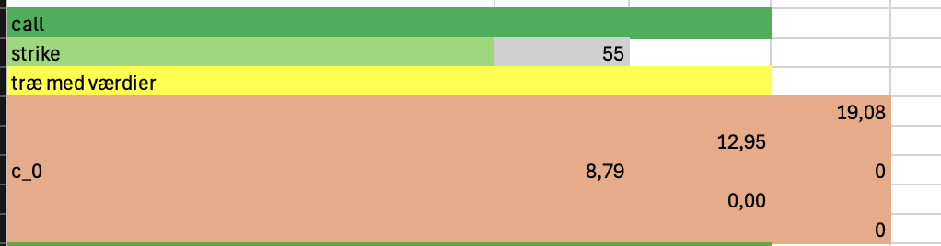
This is the total value
we note that extrinsic value=0 at time 2
states:
“0” intrinsic=2 extrinsic=6.79
“u” intrinsic=$64.98-55=9,98$, extrinsic $12.95-9,98=2,97$
“d” intrinsic=0 extrinsic=0
“uu” intrinsic=19.08 extrinsic=0
“ud”intrinsic=0 extrinsic=0
“dd” intrinsic=0 extrinsic=0

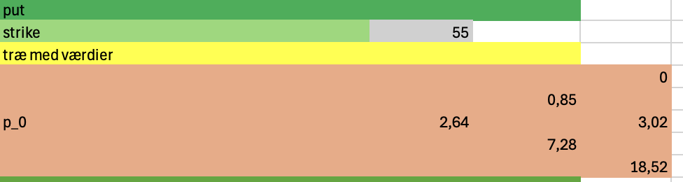
states:
“0” intrinsic=0extrinsic=2.64
“u” intrinsic=0, extrinsic=0.85
“d” intrinsic=$55-45.6=9,4$ extrinsic= $7.28-9.4=-2,12$
“uu” intrinsic=0 extrinsic=0
“ud”intrinsic=3.02 extrinsic=0
“dd” intrinsic=18.52 extrinsic=0

Q3
We solve the system of equations
$$c_{uu}=Δs_{uu}+\frac{B}{d_{1,2}}$$
$$c_{ud}=Δs_{ud}+\frac{B}{d_{1,2}}$$

$$19.08=Δ·74.08+1.04·B$$
$$0=Δ·51.98+1.04·B$$
$⇕$ Ligningssystemet løses for Δ,B vha. WordMat's 'Løs Ligninger' funktion,
$$Δ=\frac{954}{1105}≈0,8633484$$
$$B=-\left(\frac{1239723}{28730}\right)≈-43,150818$$
Q4
We create a new tree and see that it is no longer recombining
I assume that up and down values stay the same
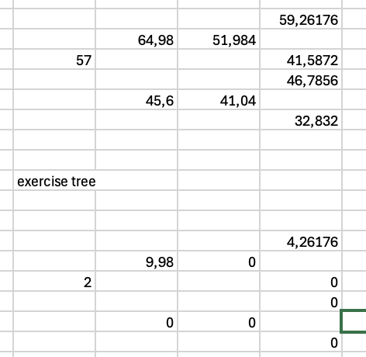
Since extrinsic value is 0 at time 1 we can simply treat it as a european for now
Pricing like the european we get
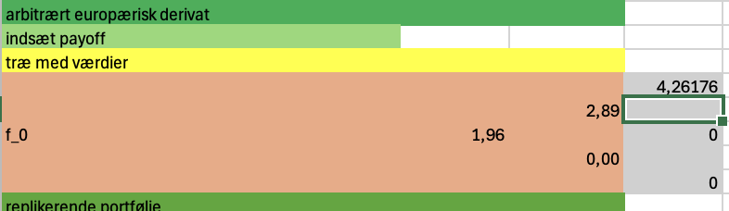
Then
$$c_{0}^{A}=\max{c_{o}^{E},2}=2$$
Thus the price of the call should be 2 and you should always exercise right away
Q5
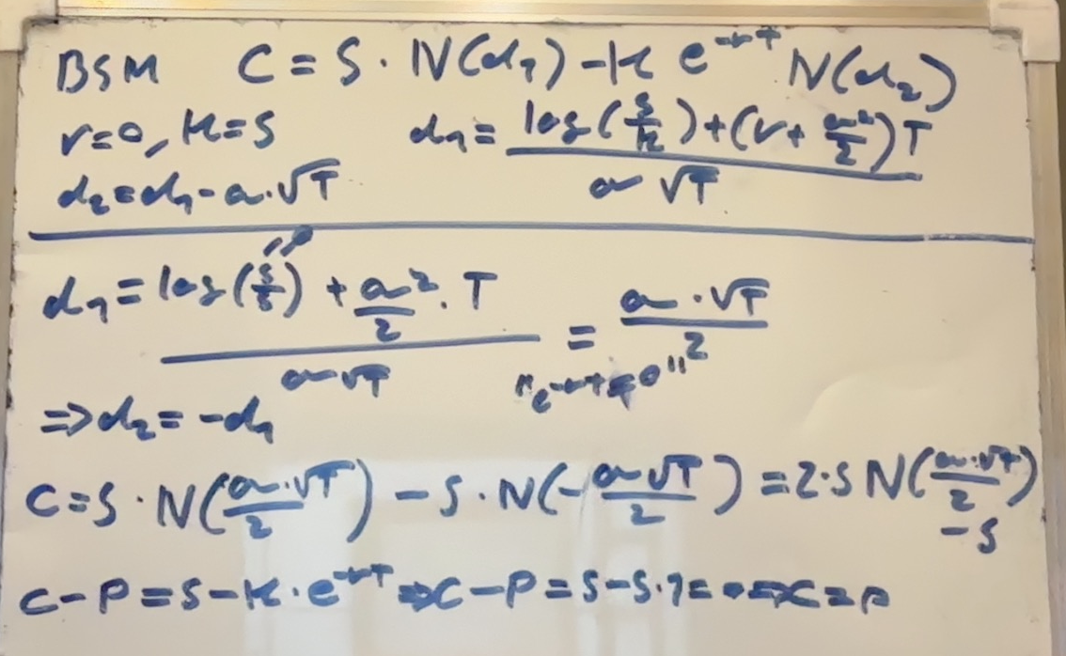

Exercise 4
Q1
Im assuming we are talking about a 2 period commodity swap
$$X=2·\frac{8}{\frac{1}{1.02}+\frac{1}{{1.02}^{2}}}=8,240792079207921$$
Q2
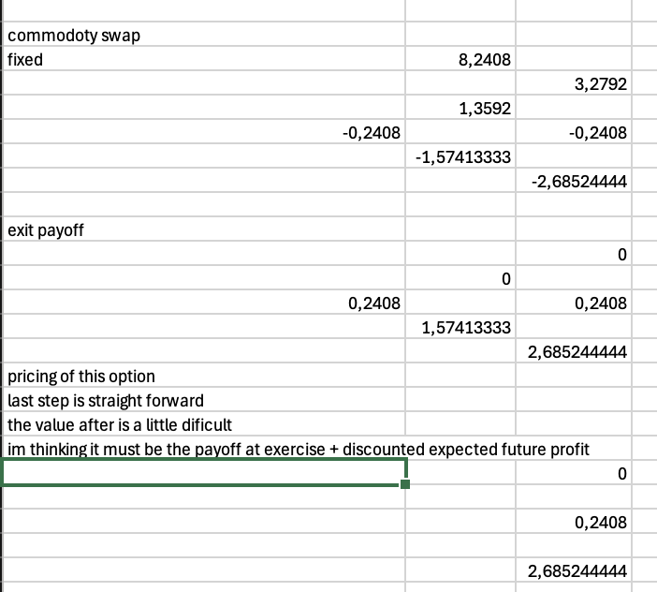
The idea is if we exercise we exit the clause(or at least that’s what I read it as)
Thus if we exercise we also need to price the expected profit/loss that brings and take that into account
C_u
$$value if exercised=-13,3592+\frac{1}{1.02}·\left(-3.2792·0.50909+0.2408·\left(1-0.50909\right)\right)=-14,879981176470588$$
Thus since $<0$ we do not exercise if we go up and simply price it as a european
$$c_{u}=\frac{1}{1.02}·\left(0.2408·\left(1-0.50909\right)\right)=0,12878078431372547$$

C_d
$$Value if exercised=1.57413+\frac{1}{1.02}\left(0.50909·0.2408+\left(1-0.50909\right)·2.68524\right)=2,986679059215686$$
$$value otherwise=\frac{1}{1.02}\left(0.50909·0.2408+\left(1-0.50909\right)·2.68524\right)=1,412549059215686$$
We see that the value is higher if we exercise
Thus
$$C_{d}=2,986679059215686$$
We will be indifferent between exercising and not since it’s a fair commodity swap thus we simply need to price it
$$c_{0}=\frac{1}{1.02}·\left(0.50909·0,12878078431372547+\left(1-0.50909\right)2,986679059215686\right)=1,5017172808292616$$
That is then the exact price one would need to pay for the early stopping clause

Q3
We have fixed costs of carry
$$c=0.25$$
We then find the forward price of the commodity
$$X=\frac{8+0.25·\left(\frac{1}{1.02}+\frac{1}{{1.02}^{2}}\right)}{{\frac{1}{1.02}}^{2}}=8,828199999999999$$
Q4 convinience yield
In the market $X^{m}=6.33$
Thus we must have
$$\frac{8+\left(0.25-y\right)·\left(\frac{1}{1.02}+\frac{1}{{1.02}^{2}}\right)}{{\left(\frac{1}{1.02}\right)}^{2}}=6.33$$
$⇕$ Ligningen løses for y vha. WordMat.
$$y=1,2367327$$

Since the convinience yield is positive people would like to hold the asset

Q6
$$dD_{t}=μ·D_{t} dt+σ·D_{t} dw_{t}$$
$$P_{t}={\left(D_{t}\right)}^{2}+γ·\sin\left(2πt\right)$$
Itos lemma
$$dP_{t}=\left[\frac{∂P}{∂t}+μ·D·\frac{∂P}{∂D}+\frac{1}{2}σ^{2}·D^{2}·\frac{∂^{2}P}{∂D^{2}}\right]dt+σ·D·\frac{∂P}{∂D} dw_{t}$$
$$\frac{∂P}{∂t}=γ·2π·\cos\left(2πt\right)$$
$$\frac{∂P}{∂D}=2D$$
$$\frac{∂^{2}P}{∂D^{2}}=2$$
$$dP_{t}=\left[γ·2π·\cos\left(2πt\right)+μ·D^{2}·2+\frac{1}{2}σ^{2}·D^{2}·2\right]dt+σ·D^{2}·2 dw_{t}$$
$$=\left[2·D_{t}^{2}\left(μ+\frac{1}{2}σ^{2}\right)+γ·2π·\cos\left(2πt\right)\right]dt+2σ·D_{t} dw_{t}$$

